Bridgepoint Parts Catalog

Section XXIV: Maintenance Items Page 1

PXX001

Oil 30W

Motor Oil - Quart
(Brand Name May Vary)

PXX002

Oil 30W Non-Detergent

Motor Oil - Quart
(Brand Name May Vary)
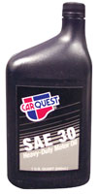
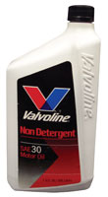

PXX004

Oil 10W-30

Motor Oil - Quart
(Brand Name May Vary)

PXX006

Oil 5W-30 Synthetic

Motor Oil - Quart
(Brand Name May Vary)

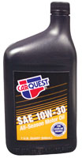
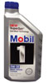

PXX005

Oil 10W-40

Motor Oil - Quart
(Brand Name May Vary)

PXX007

Oil 5W-30

Motor Oil - Quart
(Brand Name May Vary)
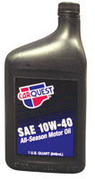
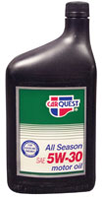

PP05-008039

Oil Aeon PD Synthetic

Blower Oil - Quart

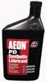

PXX008

Oil 15W-40 Diesel Rated

Motor Oil – Quart
(Brand Name May Vary)

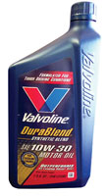

PST8106101

Oil Cat Pump Crankcase

21oz. Bottle
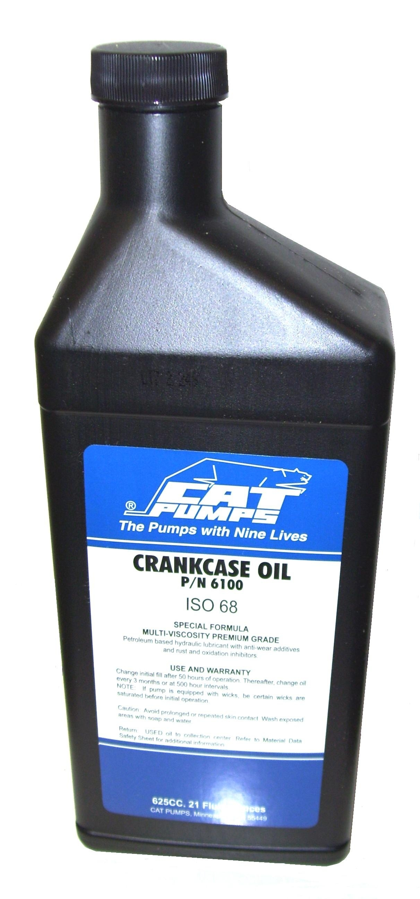

PXX009

Oil 20W-50

Motor Oil – Quart
(Brand Name May Vary)

PXX010

Anti-Freeze – Standard

Green - Gallon
(Brand Name May Vary)

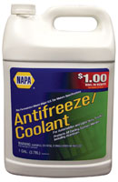

PP05-008035

Synthetic Multi-purpose Grease with Teflon

3oz. Tube
(Brand Name May Vary)

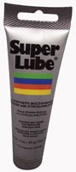

PXX011

Anti-Freeze – GM Dex-Cool

Red - Gallon
(Brand Name May Vary)

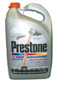

CR85AE

Moisture Guard - Lubricant

Liquid Wrench
12oz. Aerosol
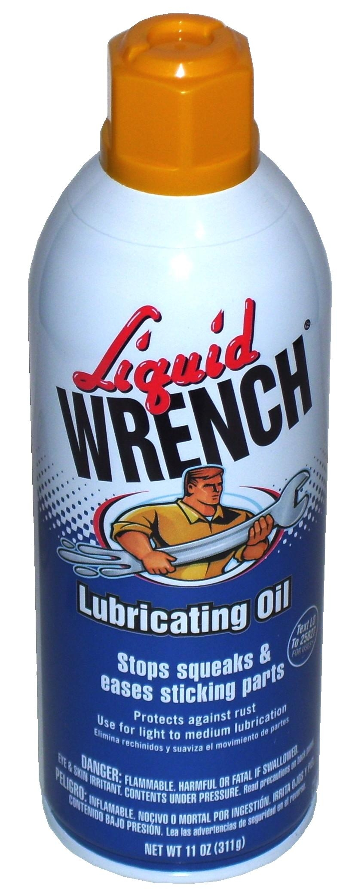

PHY087-034

Pneu-Lube Blower Oil

Quart Bottle

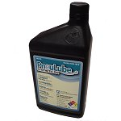

PXX012

General Pump Oil – Series 100

Quart Bottle

Pint Bottle: PP791106

CR89GL

De-Scaler – SafeClean

Non-acid Formula

Gallon

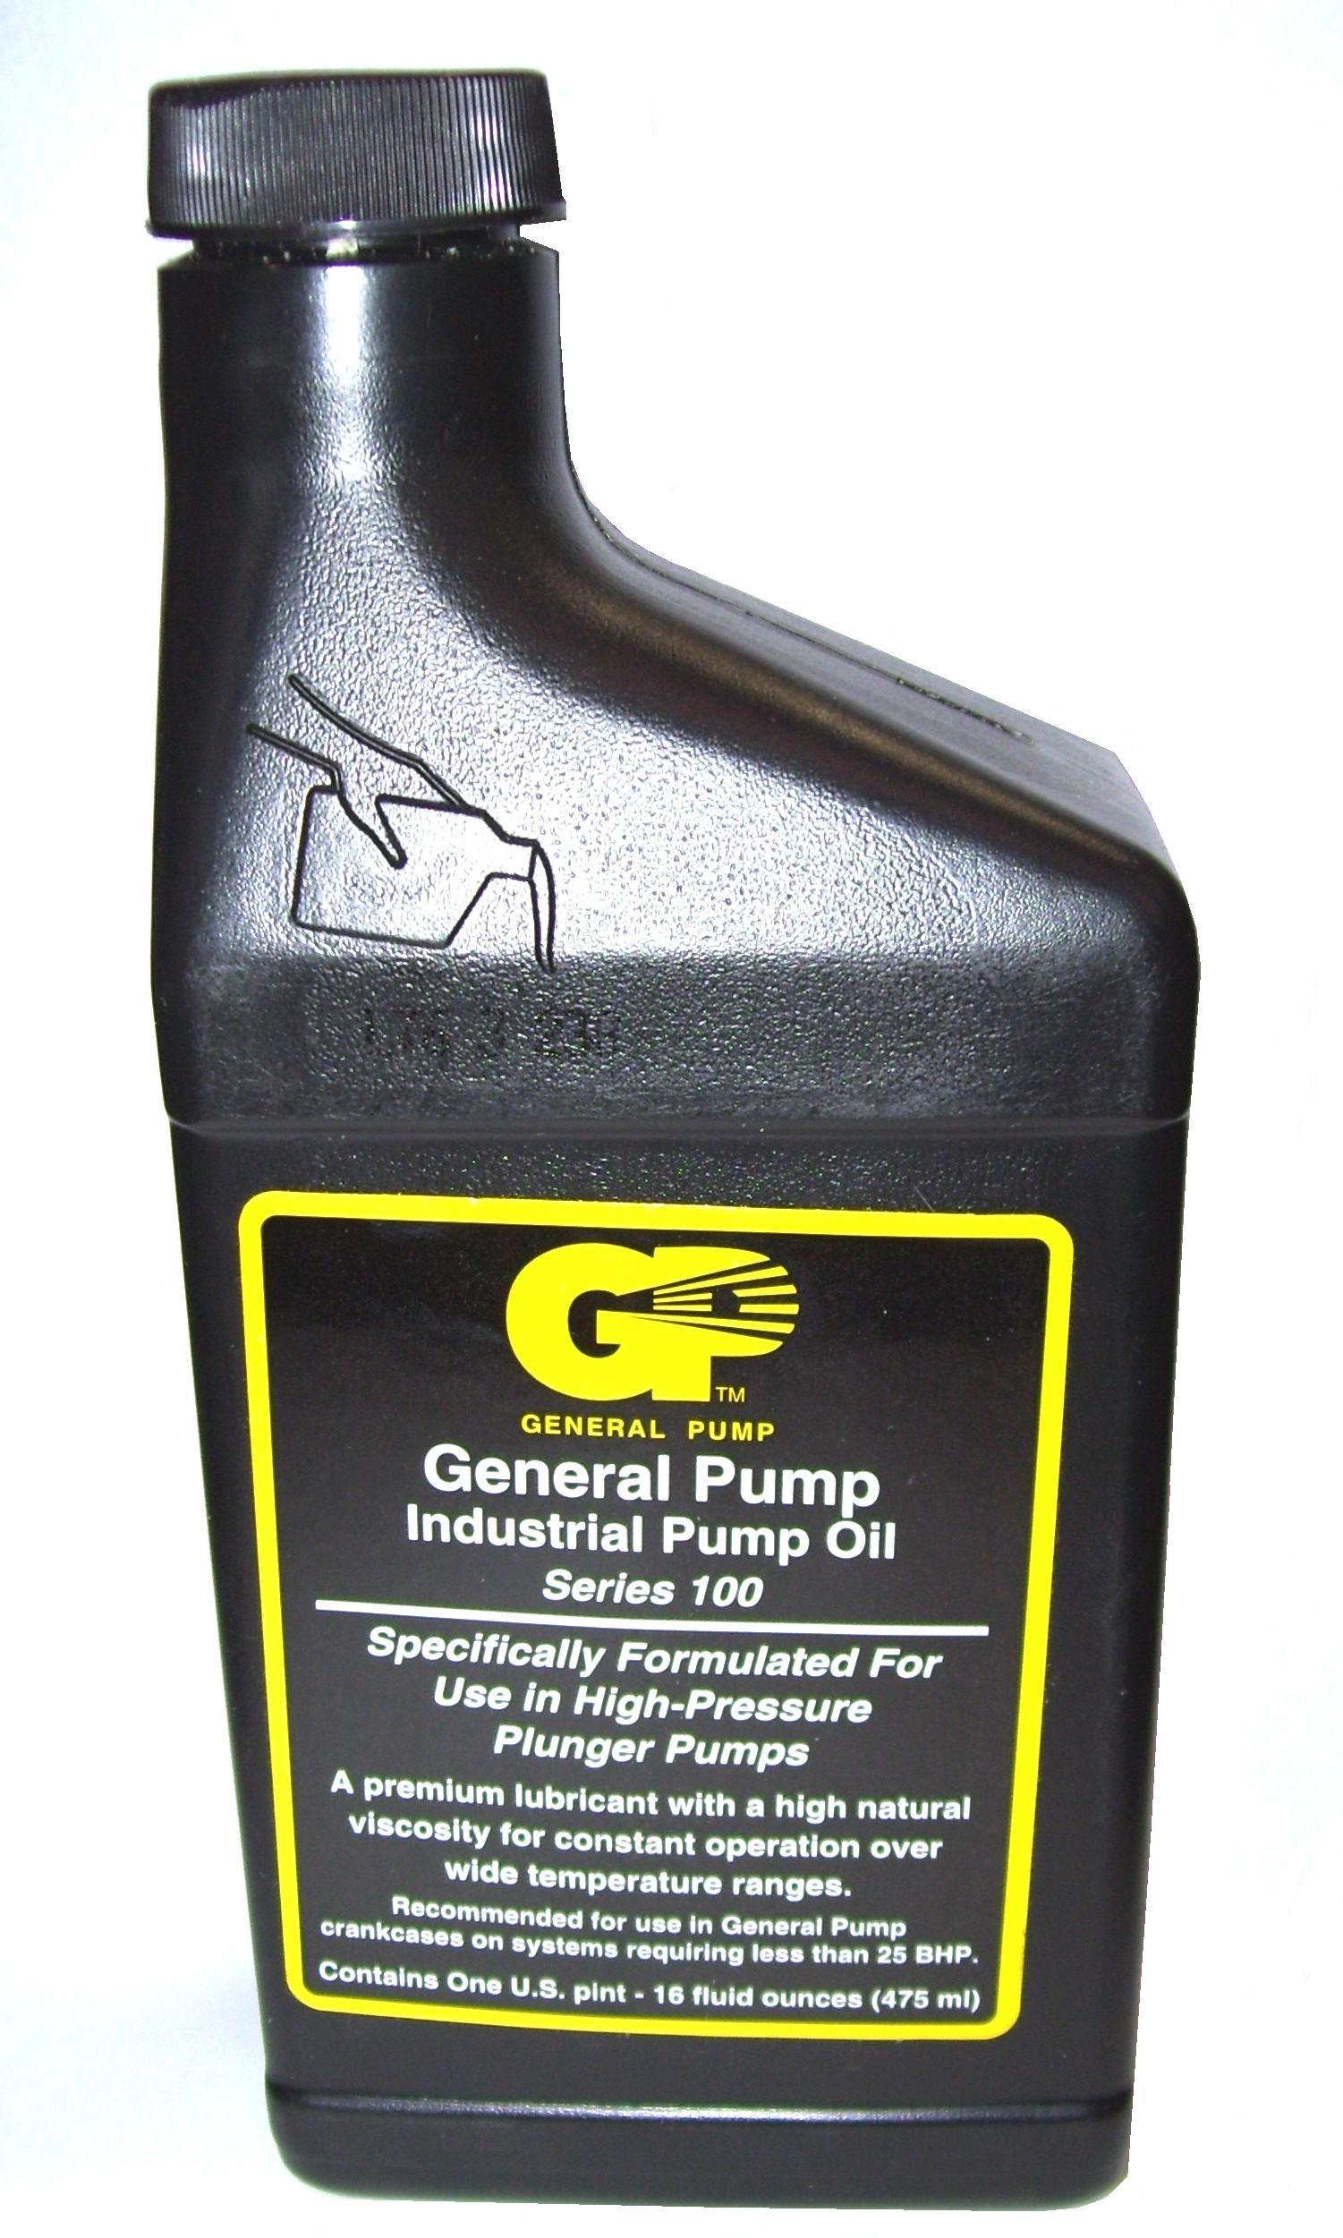
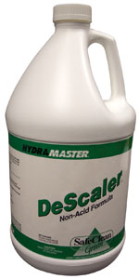

CR87GL

Aci-Det De-scaler

Inhibited Hydrogen Chloride

WCC12

Truck Mount De-scaler

Powdered Formula

2lb. Jar

